**Secure Access Entry System**

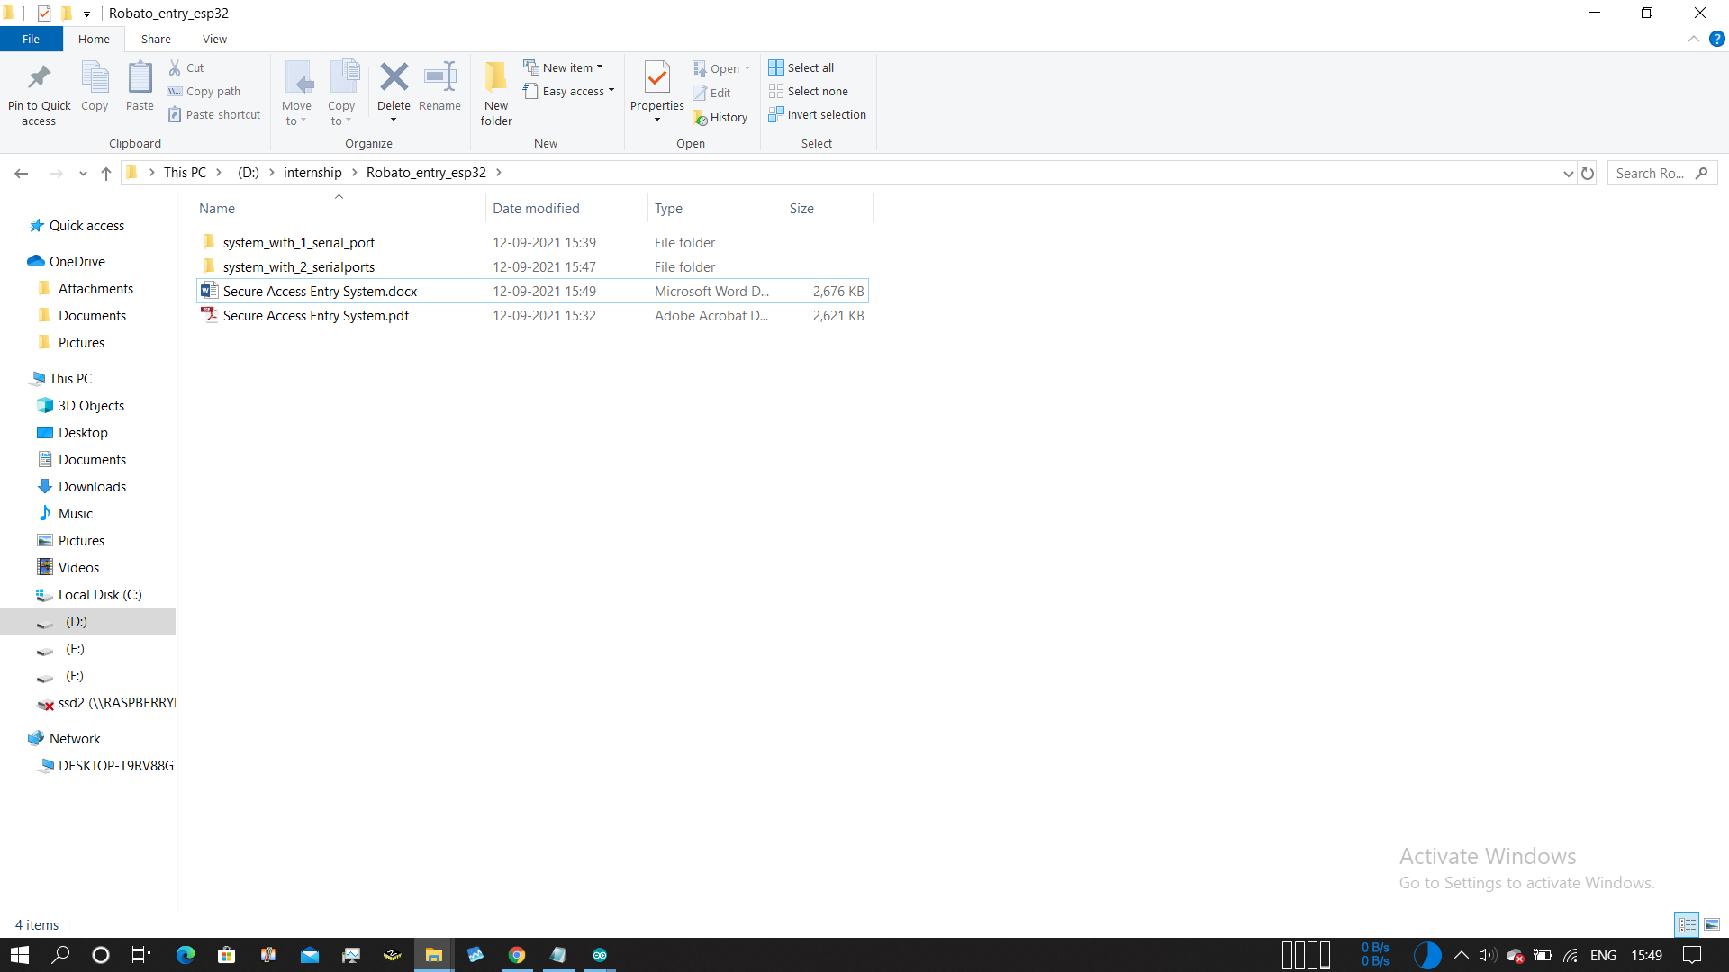

**system_with_1_serial_port folder files**

These files take input parameters and also shows debug outputs on same serial port

**system_with_2_serial_ports_folder files**

Takes input from Serial port2 and shows output on serial port2

* Upload ESP32_ENTRY_WITHOUT_BUSY_STATE.ino code to the esp32 and open the serial monitor

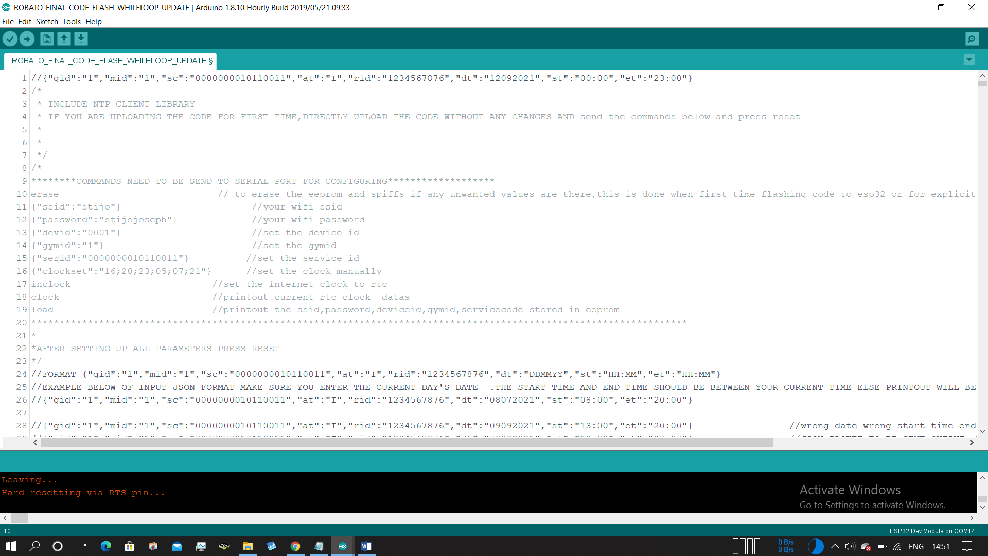

* Copy the command from line 10

“erase” and enter into the serial monitor

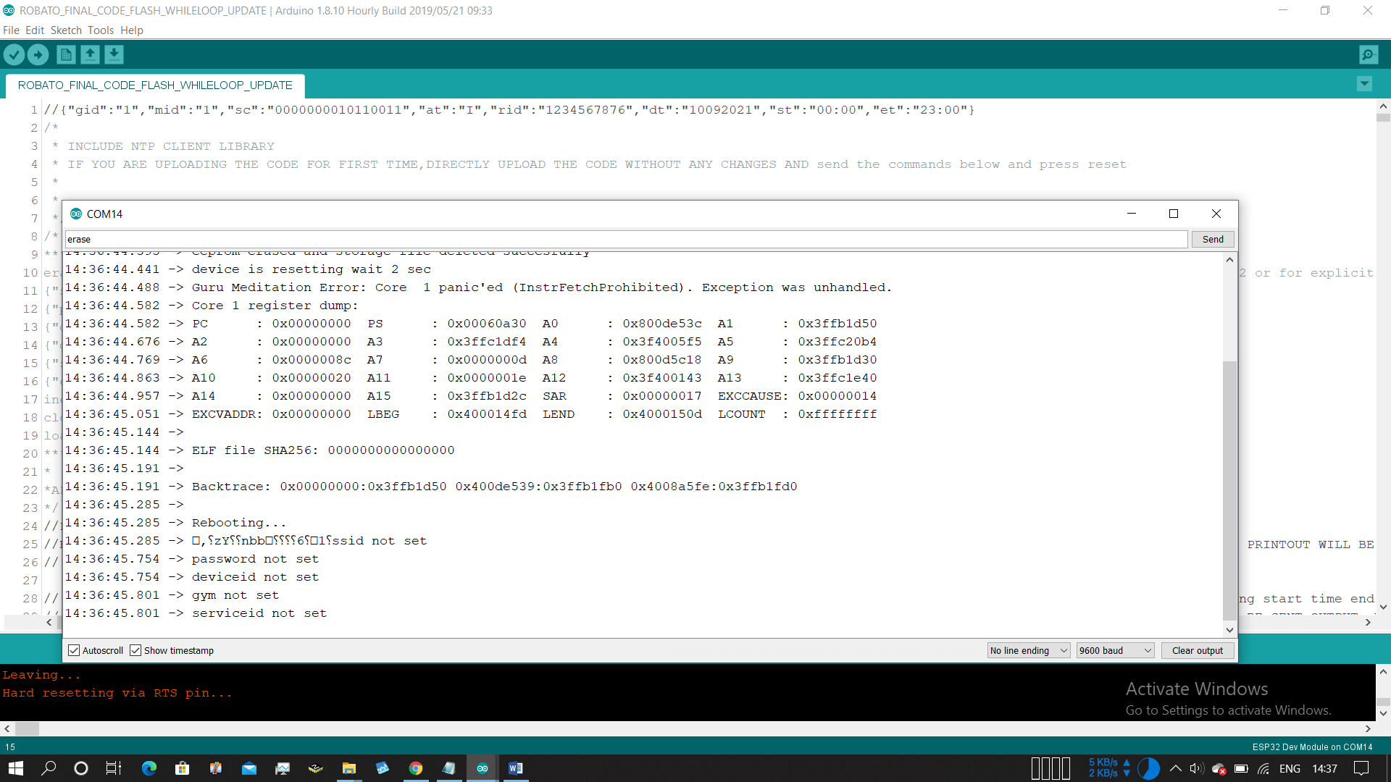

* All datas will get erased and the system restarts

Next copy the line 11

{"ssid":"stijo"}

{"ssid":"yourSSID"}

* Replace it with your ssid and enter into serial monitor

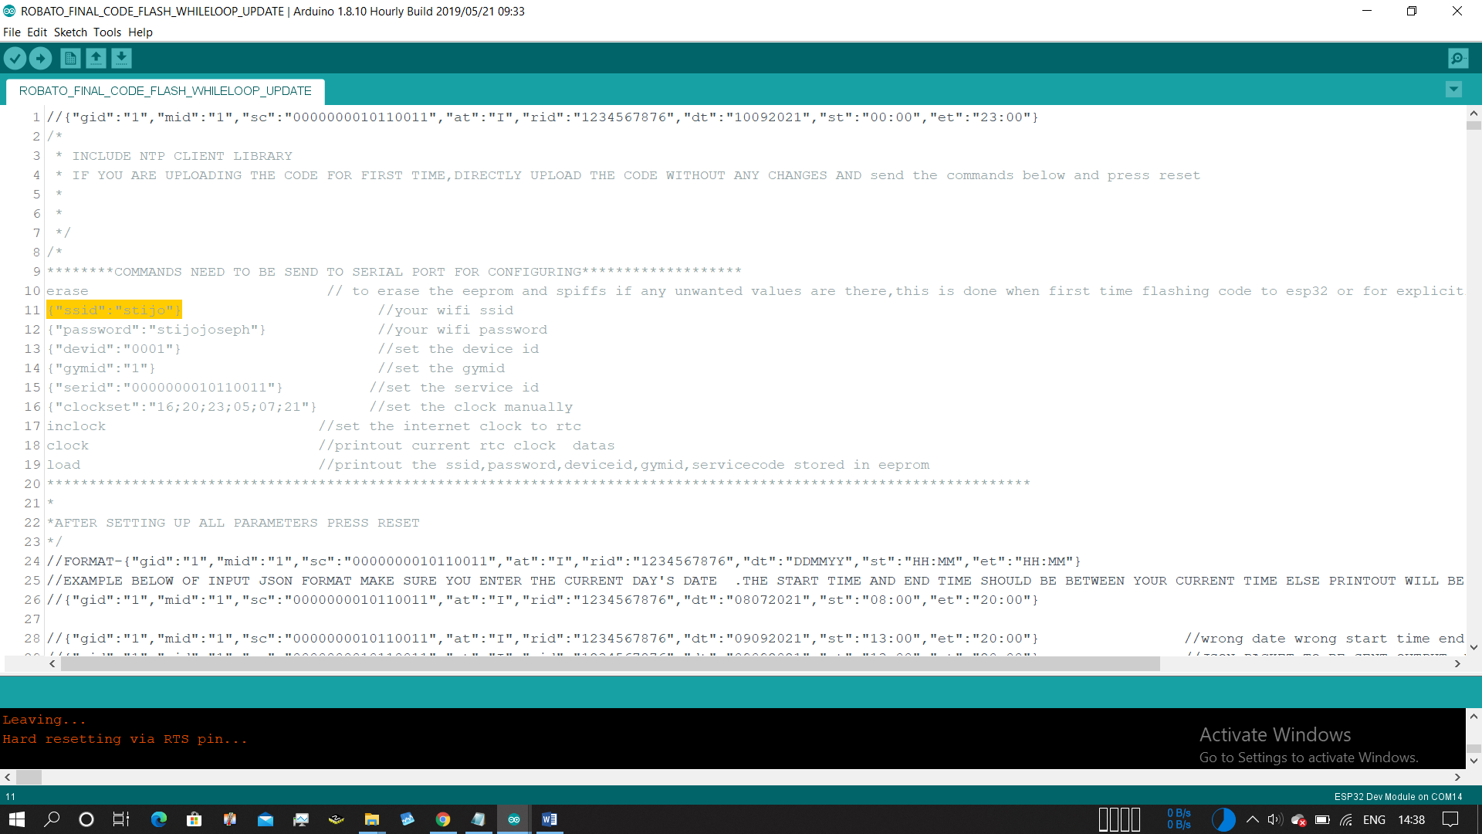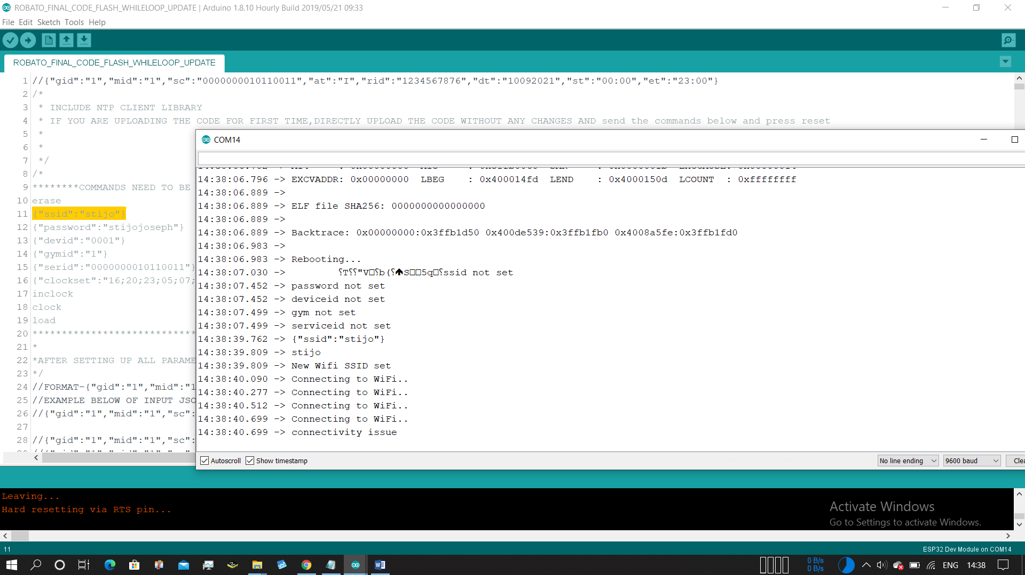

* Output will be new Wifi ssid set ,next silimlary copy 12th line and set password

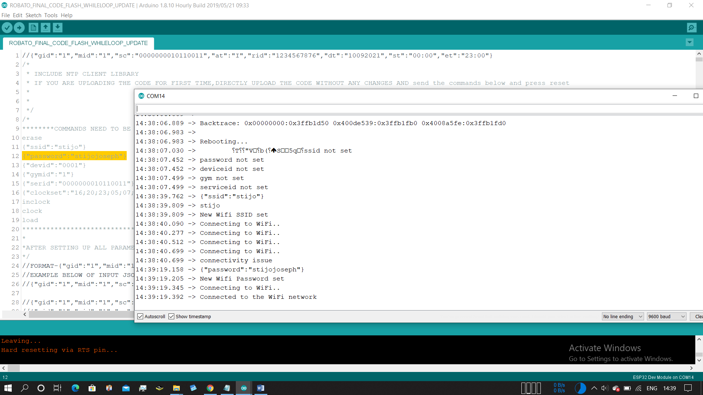

* It will show connecting wifi,then Connected to wifi network
* Make sure you put the correct ssid and password

Possible error situtaion

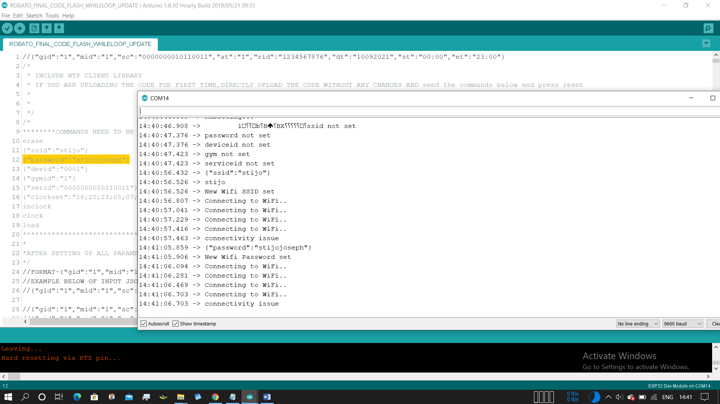

* If you get any connectivity issue even after entering correct ssid and password, that will be solved on next a device reset
* Now set the remaining parameters from line 13

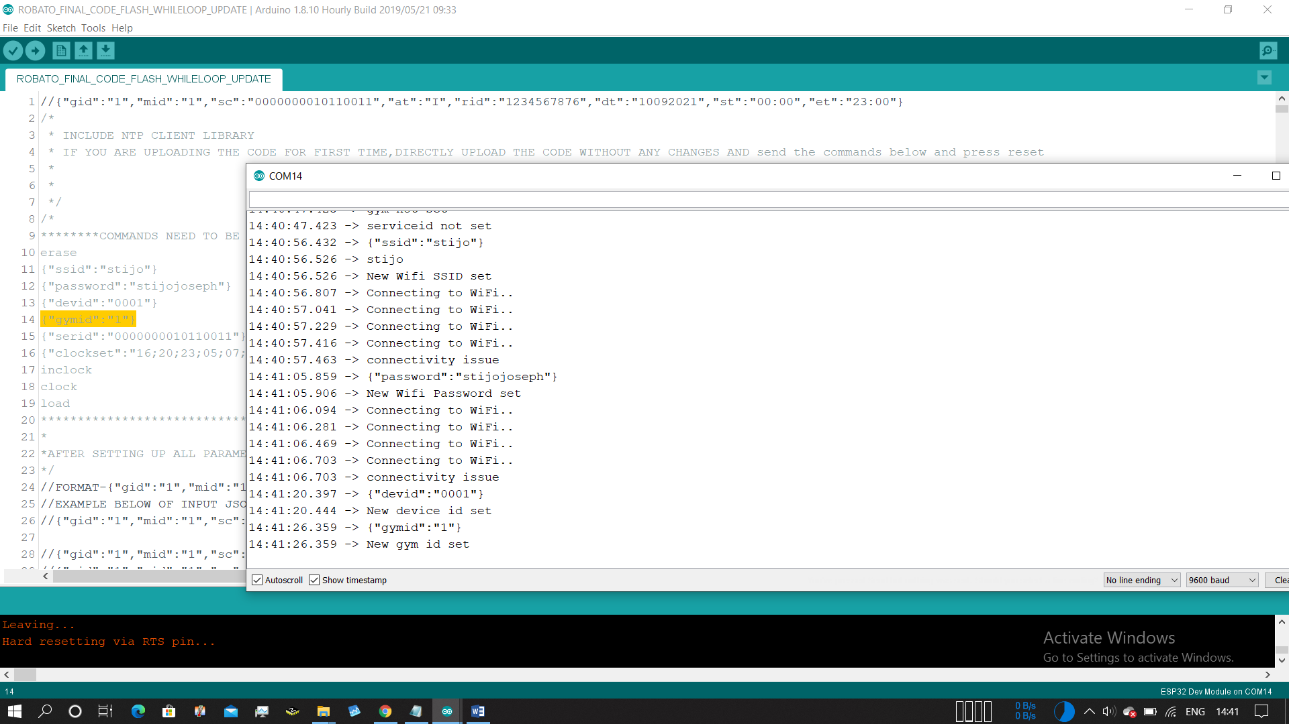

Similary set gymid,deviceid

{"devid":"0001"} //set the device id

{"gymid":"1"} //set the gymid

{"serid":"0000000010110011"} //set the service id

{"clockset":"16;20;23;05;07;21"} //manual clock set if needed

{"clockset":"HH;MM;SS;DD;MM;YY"}

inclock //set the internet clock to rtc

clock //printout current rtc clock datas

load //printout the ssid,password,deviceid,gymid,servicecode stored in eeprom

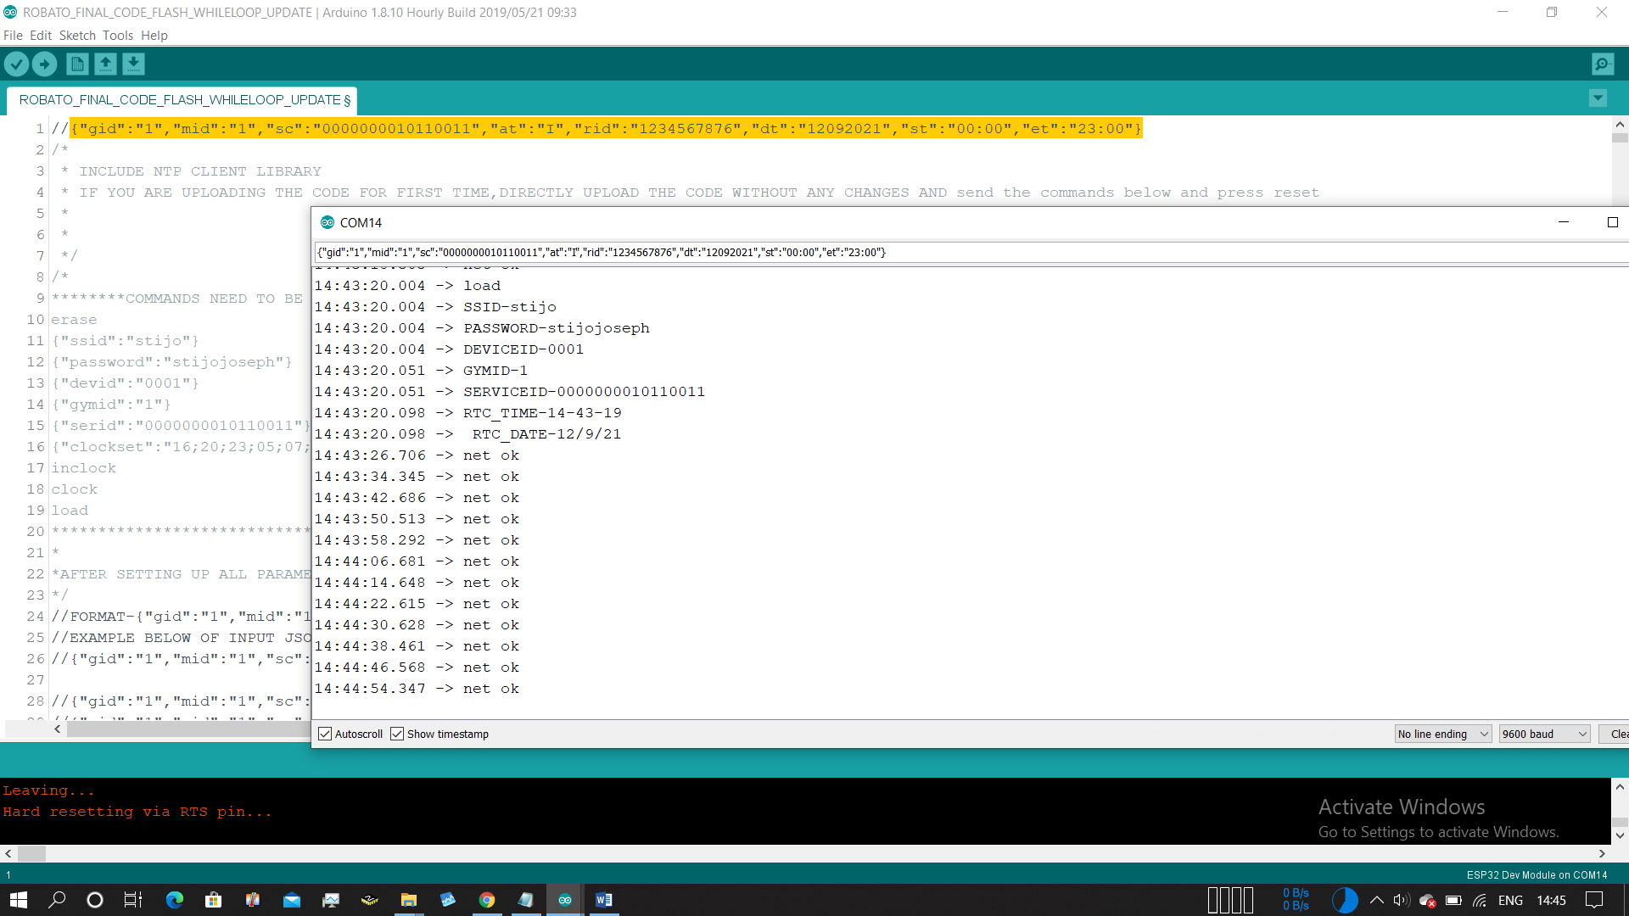

Load command output

* Press reset button of the Esp32 ,so that device reset

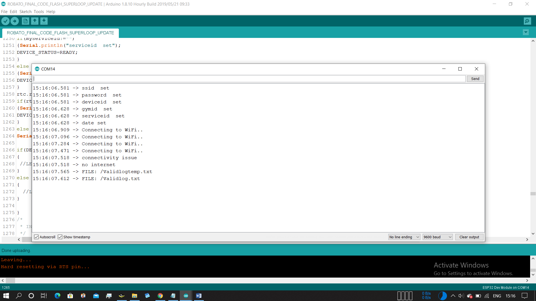

ssid set

password set

deviceid set

gymid set

serviceid set

date set

* if any of these paramaters are not set try reconfiguring using its particular commands
* “net ok” this keeps on outputting onscreen which means internet and wifi connectivity is ok

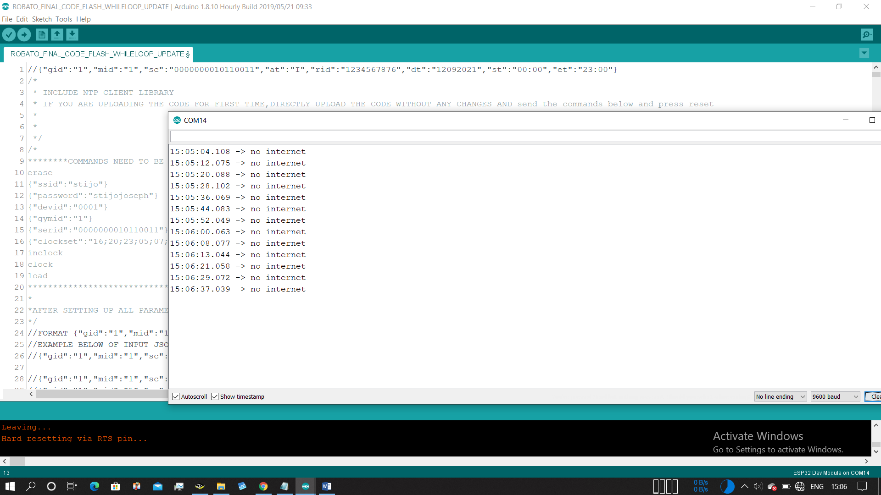

* If internet connectivity is lost “no internet” is printed out

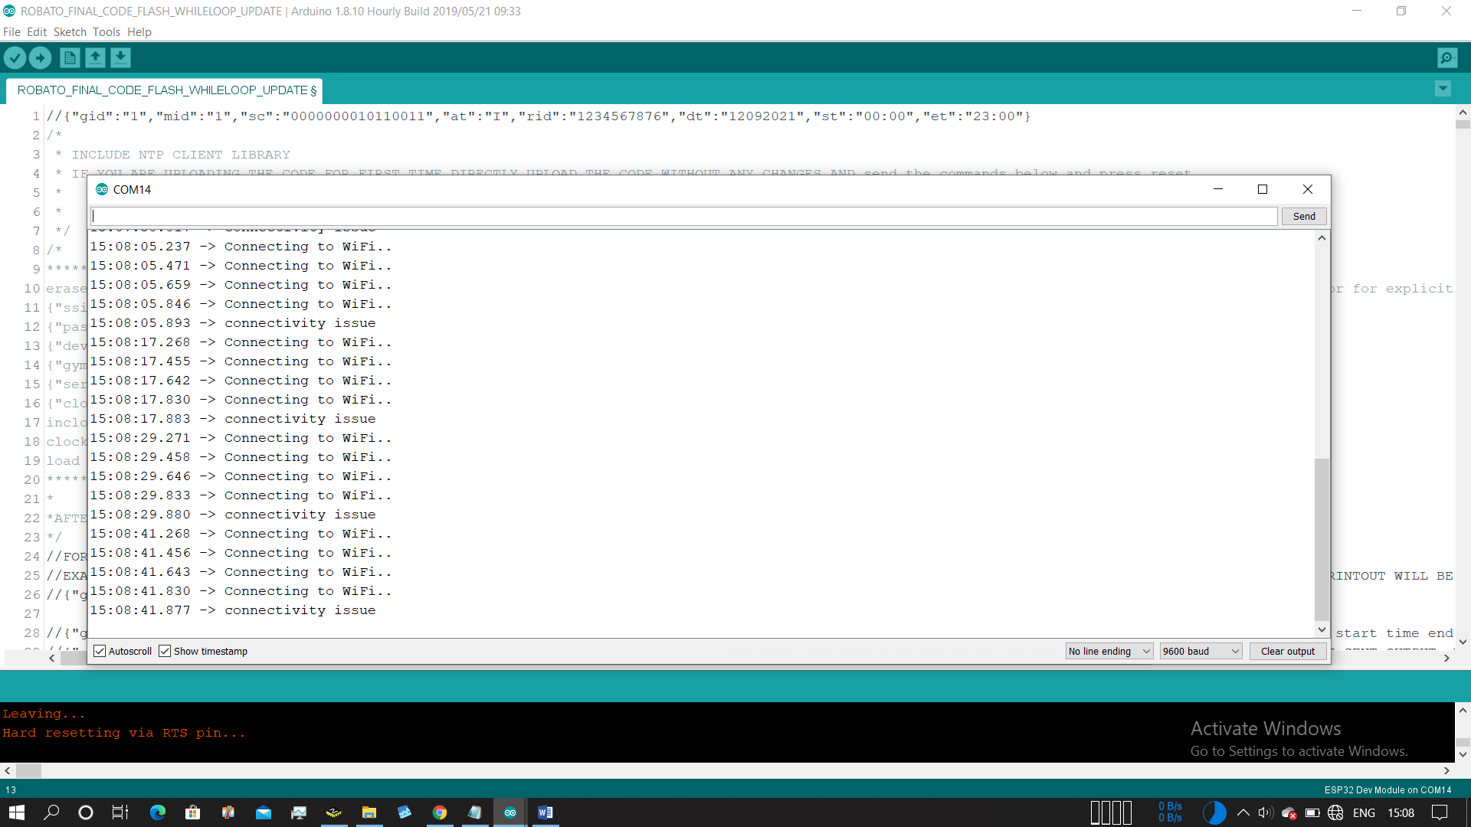

* If wifi accesspoint is not there or any connectivity issue

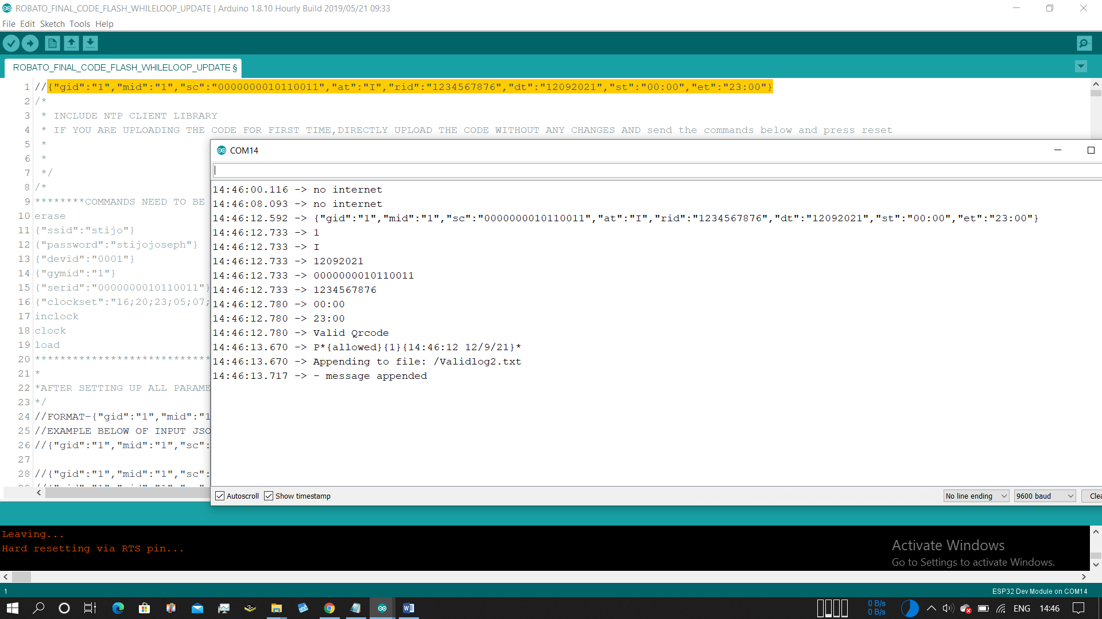

* Copy the first line , set the current date

{"gid":"1","mid":"1","sc":"0000000010110011","at":"I","rid":"1234567876","dt":"12092021","st":"00:00","et":"23:00"}

{"gid":"1","mid":"1","sc":"0000000010110011","at":"I","rid":"1234567876","dt":"DDMMYYYY","st":"00:00","et":"23:00"}

* Then enter it into serial monitor

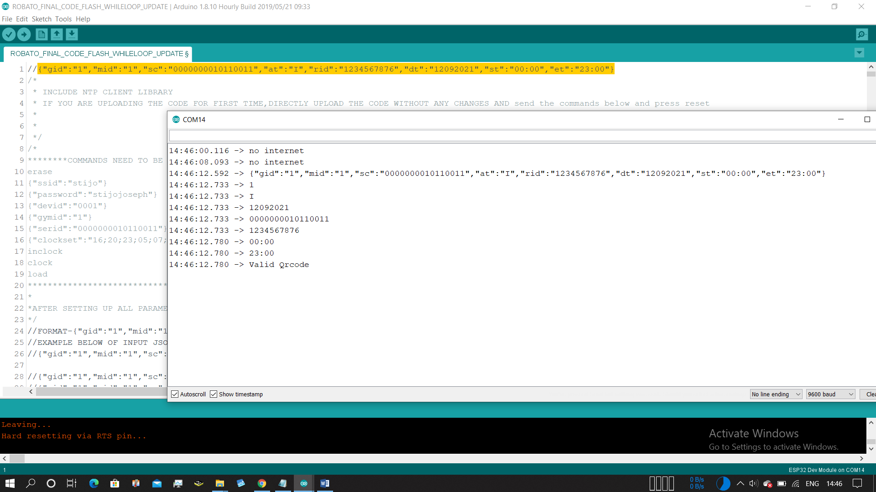

* If your paramters on flash matches the incoming json parameters the output will be this
* And based on internet connectivity it will send it to the server or will write it into the flash file

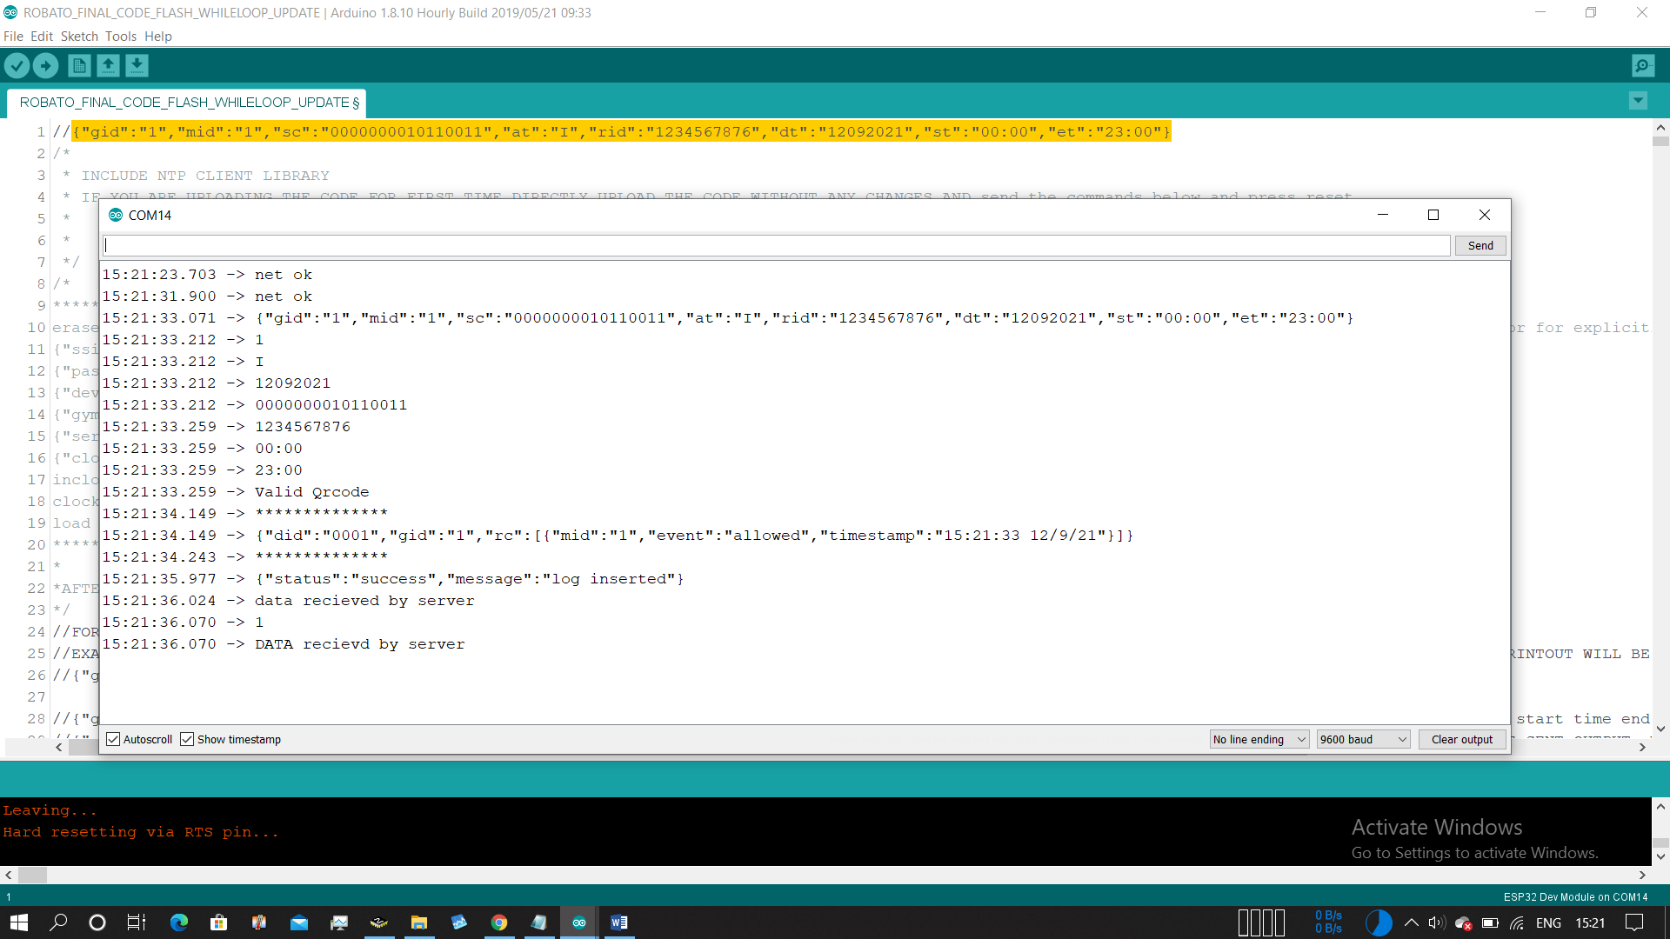

Eg:data uploaded to server



Eg: Data appended to file due bad internet connectivity

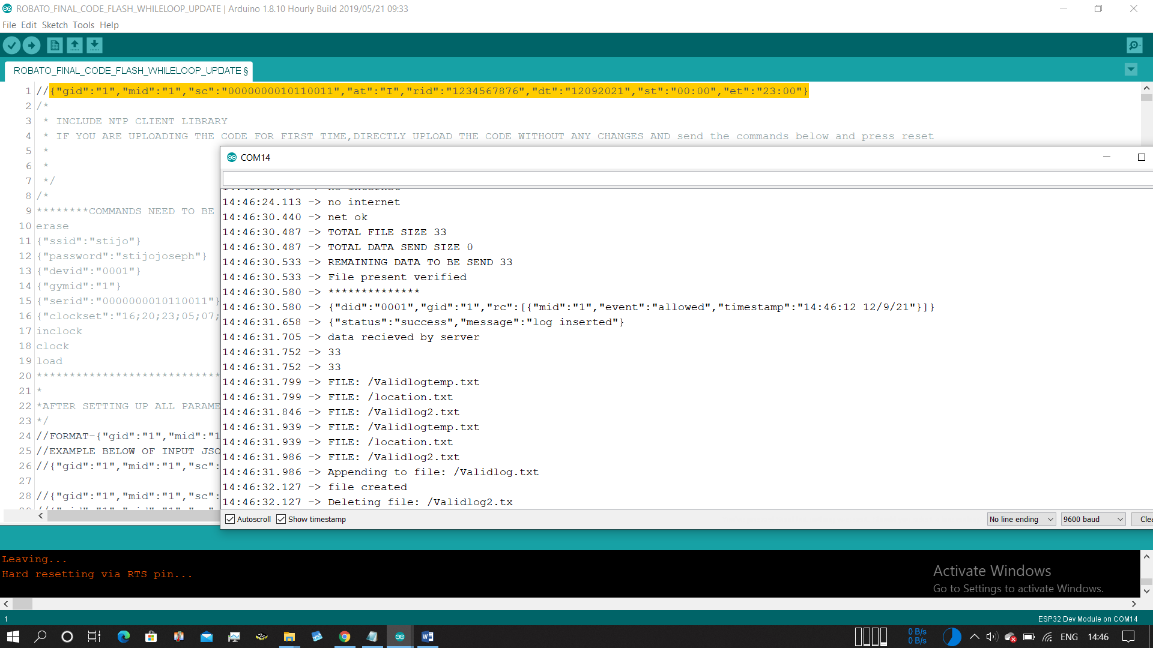

Eg:Automatic update data from file to server when internet connectivity comes back